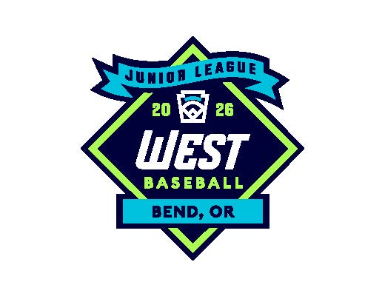

2026 West Region

Junior Baseball Tournament

July 22, 2026 – July 31, 2026

Bend, Oregon

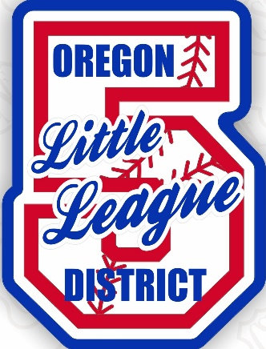

Welcome

Oregon District 5 Little League would like to welcome you to the Little League West Region Junior Baseball tournament. Each team has played their best to reach this pinnacle and one skilled team will be crowned the champion of the West Region and go on to play for the Little League World Series Title.

Tournament Host

Oregon District 5 Little League
Elizabeth Hisatake, District Administrator oregond5da@gmail.com 541.598.5351
Julie Mitchell, District Staff juliemitchell893@gmail.com 541.777.0473
Greg Anderman, Regional Umpire Coordinator greg.anderman@otis.com 714.493.4929
David Kramer, Regional Umpire Coordinator dave.kramer09@gmail.com 541.480.2510

Tournament Format
The tournament is a modified double elimination tournament.

Dates
Tournament play will take place from July 22, 2026 – July 30, 2026. The weather can play a factor in the schedule and as a result, play may be done at a different location, i.e. turf baseball field which means having molded/turf cleats as well.

Tournament Location
All Games will be played at Caldera High School Varsity and JV baseball fields 60925 SE 15th St. Bend, Oregon 97702

Mandatory Managers Meeting
All managers (coaches are encouraged to attend) must report to a Mandatory meeting at Caldera High School at 5pm on July 21, 2026, to go over all the information and structure for the tournament. Please provide your cell phone number and email address, this allows for direct communication during the tournament.

Team Registration
Each state will forward their champion team’s information to the tournament director. Each team’s manager will bring their team affidavits to the mandatory managers meeting on July 21, 2026 at 5pm for a certification check (affidavit binder).
Affidavits, proof of residency, coach’s requirements, Oregon Concussion (Senate Bill 721) and medical releases will be checked at this time. If any team has an incomplete affidavit, West Region must be consulted to determine if that team is allowed to play, so please make sure your Affidavit is complete before you travel.

Team & Tournament Listing
Once a team has been crowned as the state champion, please click on the link and provide your team information in the google excel document. Once the document is updated, the information is there for all teams and district 5 staff to be aware. Please make sure to complete this task.
CORRECT VERSION 2026 WRLL JR BB Team listing_042426.xlsx

Airport Access
There are two major airports available for transportation into Bend.
- Roberts Field Redmond Oregon (15 miles)
Redmond Municipal Airport (RDM) is located in the heart of Central Oregon and is currently served by four air carriers; Alaska Air, American Airlines, Delta Airlines, and United Airlines with daily direct flights to Denver, Portland, Los Angeles, Phoenix, San Francisco, Salt Lake City and Seattle.
http://www.flyrdm.com/

- Portland International Airport (150 miles)
Located in Portland Oregon, Portland International Airport (PDX) is served by Alaska Airlines, American Airlines, Delta Airlines, Hawaiian Airlines, Southwest Airlines, United Airlines and several specialty carriers.
http://www.flypdx.com/PDX

Weather

Bend is considered high desert meaning during the day it’ll be warm (may even be hot) and during the night it’ll cool down. Here is the weather link for your review to determine appropriate attire to bring.

https://forecast.weather.gov/MapClick.php?lon=-121.291&lat=44.015

Lodging

There are several different lodging accommodations listed, there are a few hotels that have provided a block of rooms, however there are a few establishments that chose not to provide a room block, but did offer their establishment for general lodging. If you have questions or concerns, please contact Elizabeth Hisatake at 541.598.5351.

Holiday Inn Express / 61070 S. Highway 97 Bend, OR. 97702 / 541.585.7474

Reservation group block: Little League International

Reservation link: Holiday Inn Express reservation link

20 double queen room reservation established 07.21.2026 – 07.30.2026

RESERVATION CUT-OFF: 06.21.2026

Hampton Inn & Suites Bend / 730 SW Columbia St. Bend, OR. 97702 / 541.388.3000

Reservation group block: Little League International

Reservation group code: 90H

Reservation link: Little League International - Hampton Inn and Suites Bend

10 double queen room reservation established 07.21.2026 – 07.30.2026

RESERVATION CUT-OFF: 06.16.2026

LaQuinta Inn by Windham Bend / 61200 S. Highway 97, Bend, OR. 97702 / 541.388.2227

Reservation group block: Little League International (OR Hisatake sports)

10 double queen room reservation established 07.21.2026 – 07.30.2026

RESERVATION CUT-OFF: 06.21.2026

Country Inn & Suites by Raddison / 62065 SE 27th St. Bend, OR. 97701 / 541.903.5226

Reservation group block: Little League International

Reservation link: https://www.choicehotels.com/reservations/groups/TZ10M8

15 King suites established 07.21.2026 – 07.30.2026

RESERVATION CUT-OFF: 06.21.2026

Hotel Peppertree Bend / 1082 SW Yates Drive Bend, OR. 97702 / 800.780.7234

Reservation link: https://www.bestwestern.com/en_US/book/hotel-rooms.38175.html?promoCode=15PERCENTOFF

**If you’d like to reserve a block of rooms for your team, call Khara Nixon- 509.720.8366 and explain that you’re wanting a block of rooms for the team and Khara will work with you.

ALTERNATIVE HOTELS DID NOT PROVIDE A BLOCK OF ROOMS, BUT YOU CAN CONTACT DIRECTLY FOR RESERVATIONS.

Home 2 Suites / 541.797.7782

Towne Place Suites / 541.382.5006

Fairfield Inn & Suites / 541.318.1747

Red Lion Inn & Suites / 541.388.4114

Opening Ceremonies & Challenger Game
There will be an opening ceremony breakfast in honor of the teams that have made it this far. This event will take place at the Caldera High School Varsity field located at 60925 SE 15th St. Bend, Oregon 97702. All players and managers are required to attend, and admission is free. Opening Ceremonies will consist of all teams being lined up on the varsity field, each team will be presented.
The breakfast will be available for the players, manager/coaches, umpires, volunteers. If there’s potential for families to attend the breakfast, notification will be provided to teams.
A Challenger game is being coordinated and we’ll encourage players to become a challenger player buddy during the game.

Game Results
Results of all games will be reported daily through the District 5 website: Oregon District 5 Little League, the electronic program and Little League International.

Spectators are allowed to broadcast the games however, the two fields have net backstops, and no equipment is allowed to be mounted on the netting.

Tournament Rules
2026Tournament Rules and Guidelines for Little League Baseball will be strictly adhered to.

Tournament Ground Rules and the Oregon State District Administrators Association Code of Conduct will be enforced at the tournament. Please see the attached documents.

Umpires
Umpires will be provided by Little League West Region, no umpires will be assigned games in which their home league participates. If at all possible, no umpires will be assigned games in which their home district participates.

Greg Anderman, Oregon District 5 Regional Umpire Coordinator
Email: greg.anderman@otis.com / Cell phone: 714.493.4929
David Kramer, Oregon District 5 Regional Umpire Coordinator
Email: dave.kramer09@gmail.com / Cell phone: 541.480.2510

Equipment
Each team is required to furnish their own equipment and managers are required to ensure the equipment is safe and legal. Prior to each game, the equipment will be inspected by the designated individual/s. Batting helmets that are painted must have manufacturer’s certification letter or it will be removed. Any illegal or broken equipment will be removed from the dugout.

Concessions & Food Vendors
A Concession stand will be provided throughout the tournament; i.e. drinks, snack items, etc. In addition, there will be food vendors available, plus they’ll be providing the daily luncheon strictly between 11am-2pm ONLY for the teams that are still playing, once a team is eliminated that team is no longer able to access the food vendors for their designated luncheon meal. More information will be available at the mandatory manager’s meeting on July 21, 2026.

TOURNAMENT GROUND RULES
- All fields are considered neutral.
- All games will begin at their scheduled times. Any changes to the scheduled times must be approved by the Tournament Director.
- Teams must have a representative available one (1) hour prior to the scheduled start time of the game to conduct the DOUBLE coin toss. All teams will be assigned a randomized number and that number will determine who will call the FIRST coin toss. The winner of the FIRST coin toss will call the SECOND coin toss, and the winner (second coin toss) will have the choice of playing as the home team or visiting team.
- The home team will occupy the third base dugout, and the visitor will occupy the first base dugout.
- 30 minutes before the start of the game, the goldenrod copy of the lineup (tournament host will provide the lineup card for each team) and affidavit binder will be provided to the official score keeper.
- Each team will be allowed 7 minutes of infield practice prior to the start of the game, beginning with the visiting team 23 minutes prior to the scheduled start time.
- Eye black wear will only consist of one line, if there are designs or more than one line, the player will need to remove and apply only one line or the player will not be allowed to play during that game
- Batting cages are available at the site. Each team is allowed to have 30 minutes of cage time 1.5 hours prior to the scheduled game start time. This will be on a first-come, first-served basis.
- Junior division will utilize a continuous batting order score sheet, very similar to regular season and the maximum number of players is 14.
- All players must be in uniform prior to the start of the game. All equipment will be checked for compliance by the designated individual/s prior to the game. Illegal or broken equipment will be removed from the dugout with no exceptions.
- Managers and coaches are able to wear caps, slacks/jeans, shorts (no daisy dukes, bootie shorts), shirt, and no open toed shoes or sandals/flip flops
- All adult team personnel must be listed on the team’s affidavit.
- The designated coach to score-keep can utilize a score book or game changer in the dugout. No communication is permitted between dugout personnel and spectators.
- A pre-game conference will be held at home plate 5 minutes prior to the scheduled start time. Managers will provide completed lineup cards to the home plate umpire and scorekeeper at this time. Each player’s first and last names and jersey number must be clearly written on the lineup card. Any ineligible pitchers must be identified.
- At no time will an adult be allowed to warm-up a player.
- If pregame practice includes a bat, all players in the immediate vicinity must wear a batting helmet.
- Only players and coaches listed on the team’s affidavit will be allowed on the field or in the dugout. Any other person entering the field at any time must have permission from the Tournament Director or the home plate umpire.
- Artificial noisemakers, banging/stomping on the benches and fences IS NOT ALLOWED during the tournament.
- If flash photography or any type of noisemaker is considered a nuisance by any player, manager, coach or official, its use will be terminated for that game.
- A team is allowed to use one-way communication to the catcher while the team is on defense. During the game, no electronic devices will be authorized within the dugout during the game. Any person caught utilizing electronic devices, during the game will be ejected.
- Only the team’s manager is permitted out of the dugout to discuss rules interpretations. In a civil manner, the manager must address the specific umpire who made the call. Umpires will not address judgment calls. Violation of this rule may be cause for ejection.
- Any baseball leaving the playing field (i.e. foul balls, homeruns) must be returned to the playing field. They are the sole property of the tournament host.
- Any violation of the Code of Conduct by any manager, coach, player or spectator will be grounds for ejection.

Oregon State District Administrators Code of Conduct
The Oregon State District Administrators Association has adopted a policy of Zero Tolerance for inappropriate behavior by spectators, managers, coaches, and players at all Oregon Little League Tournament games.

The following will apply:
- Negative comments by managers, coaches, players, umpires, staff or other tournament personnel directed at managers, coaches, players, umpires, staff or other tournament personnel may result in the immediate removal of the offending person.
- If the offending person is a spectator, s/he may be barred from returning to any Oregon Tournament games hosted by the district for the remainder of the Tournament Season. If the offender refuses to leave, the game may be SUSPENDED until the offending party leaves the facility. Local law enforcement officials may be called to enforce the removal and possible charges may be filed.
- Any physical altercations with spectators, managers, coaches, players, umpires, staff or other tournament personnel will result in the offending persons being removed from the ball fields and charges being filed. Offending persons will not be permitted to return to any Oregon Tournament Site hosted with/by the District for the remainder of the Tournament Season.
- Players, manager, and coaches are not permitted to communicate during the course of the game to those outside the dugout. Spectators communicating with players, managers or coaches during the game will be asked to leave the ballpark and that player, manager or coach may be subject immediate removal from the game.
- Any player, manager or coach that uses profanity directed at an Oregon Little League tournament umpire will immediately be ejected from the game. This will also result in the hosting District to immediately ask the Tournament Committee to permanently bar that individual for the remainder of the Tournament.

It is not the intent of this Code of Conduct to deter a manager or coach from successfully directing his/her team nor is it the intent to keep spectators from positively cheering their team on. Our intent is to define our expectations for behavior while attending Oregon Little League Tournament games.

We must remember – we are adult role models for our kids, especially at these games. Therefore, be assured that we intend to enforce this code and to provide a positive experience for the players, managers, coaches and spectators and to enjoy our young people playing a game of baseball.

We request that this Code of Conduct be distributed to all leagues, teams, managers, coaches and parents of any tournament bound team. Their participation in Oregon Little League tournament games will be deemed as acceptance of this Code.
Concussion Information – Oregon Senate Bill 721
(ORS 336.485)

WHAT ARE THE SIGNS AND SYMPTOMS OF CONCUSSION?
Signs and symptoms of concussion can show up right after the injury or may not appear or be noticed until days or weeks after the injury. If an athlete reports one or more symptoms of concussion after a bump, blow, or jolt to the head or body, s/he should be kept out of play the day of the injury. The athlete should only return to play with permission from a health care professional experienced in evaluating for concussion.

SIGNS OBSERVED BY THE ATHLETE:
• Headache or “pressure” in head • Nausea or vomiting • Balance problems or dizziness • Double or blurry vision • Sensitivity to light • Sensitivity to noise • Feeling sluggish, hazy, foggy, or groggy • Concentration or memory problems • Confusion • Just not “feeling right” or is “feeling down”

SIGNS TO BE OBSERVED BY THE COACH/ES:
• Appears dazed or stunned • Is confused about assignment or position • Forgets an instruction • Is unsure of game, score, or opponent • Moves clumsily • Answers questions slowly • Loses consciousness (even briefly) • Shows mood, behavior, or personality changes • Can’t recall events prior to hit or fall • Can’t recall events after hit or fall

CONCUSSION DANGER SIGNS
In rare cases, a dangerous blood clot may form on the brain in a person with a concussion and crowd the brain against the skull. An athlete should receive immediate medical attention if after a bump, blow, or jolt to the head or body s/he exhibits any of the following danger signs:
• One pupil larger than the other • Is drowsy or cannot be awakened • A headache that gets worse • Weakness, numbness, or decreased coordination • Repeated vomiting or nausea • Slurred speech • Convulsions or seizures • Cannot recognize people or places • Becomes increasingly confused, restless, or agitated • Has unusual behavior • Loses consciousness (even a brief loss of consciousness should be taken seriously)

WHAT SHOULD YOU DO IF YOU THINK YOUR ATHLETE HAS A CONCUSSION?
1. If you suspect that an athlete has a concussion, remove the athlete from play and seek medical attention. Do not try to judge the severity of the injury yourself. Keep the athlete out of play the day of the injury and until a health care professional, experienced in evaluating for concussion, says s/he is symptom-free and it’s OK to return to play.

2. Rest is key to helping an athlete recover from a concussion. Exercising or activities that involve a lot of concentration, such as studying, working on the computer, and playing video games, may cause concussion symptoms to reappear or get worse. After a concussion, returning to sports and school is a gradual process that should be carefully managed and monitored by a health care professional.

3. Remember: Concussions affect people differently. While most athletes with a concussion recover quickly and fully, some will have symptoms that last for days, or even weeks. A more serious concussion can last for months or longer.
WHY SHOULD AN ATHLETE REPORT THEIR SYMPTOMS?
If an athlete has a concussion, his/her brain needs time to heal. While an athlete’s brain is still healing, s/he is much more likely to have another concussion. Repeat concussions can increase the time it takes to recover. In rare cases, repeat concussions in young athletes can result in brain swelling or permanent damage to their brain. They can even be fatal.

By checking the box, we acknowledge we are signing the concussion information sheet verifying we have read and understand the information concerning concussion awareness.

STATE TEAM:
PLAYER NAME &SIGNATURE | PLAYER PARENT/GUARDIAN SIGNATURE

MANAGER & COACHES NAME | MANAGER & COACHES SIGNATURE

OREGON DISTRICT 5 LITTLE LEAGUE RELEASE AND WAIVER

I, hereby give permission to Oregon District 5 Little League (ultimately Little League International), to use photographs, voice recordings, or video taken of me during the games and events associated with Oregon District 5 Little League in any manner to help promote the district/little league activities as determined in the sole discretion of Oregon District 5 Little League (ultimately Little League International). Such use could include publications, media releases, announcements, electronic or otherwise, and on league websites or social media pages.
I understand that neither I nor my child/ward will receive any compensation if such image appears in any of the manners listed above or any other manner that the league deems appropriate. I agree that such image is the property of Oregon District 5 Little League, and ultimately Little League International.

STATE TEAM:
PLAYER NAME | PLAYER PARENT/GUARDIAN SIGNATURE

MANAGER & COACHES NAME | MANAGER & COACHES SIGNATURE

PHONETIC SPELLING ROSTER
**Submit this no later than 07.15.2026 to Elizabeth Hisatake at oregond5da@gmail.com
TEAM:
DISTRICT:
STATE:

NAME PHONETIC SPELLING
Manager & Email/cell #:
Coach & Email/cell #:
Coach & Email/cell #:

Example: Tom Berringer tom bear-in-jer
Please complete this form for the announcer, turn in to the Tournament Director at your first game.
Uniform# | Player’s Name | Phonetic Spelling

West Region Junior Baseball
Schedule of Events
July 21, 2026
Teams should arrive no later than Tuesday July 21, 2026

5:00 PM
- There is a mandatory Manager (Coaches are encouraged to attend) meeting, no players in attendance for this meeting. The meeting will take place at the Caldera High School Varsity field.

5:30 PM
Tour and walk the field to become familiar with the layout. Final questions or concerns will be allowed at this time.

July 22, 2026
Opening Ceremonies 9:00am
Teams need to arrive at 8:30am to be ready for Opening Ceremonies, due to the forecasted weather (hot) during this tournament, players are allowed to wear their jersey, appropriate shorts (no bootie or daisy duke shorts) and hat. Managers and coaches are able to wear caps, slacks/jeans, shorts (no daisy dukes, bootie shorts), shirt, and no open toed shoes or sandals/flip flops
Player & coaches catered breakfast
Challenger game
Games will be played at 1:00pm and 2:00pm at Caldera High School Varsity and JV fields

July 23, 2026 – July 30, 2026
Games are scheduled at 9:00am, 10:00am, 1:00pm, 2:00pm, or alternating times

July 30, 2026
Championship game is scheduled at 9:00am

The winning team will work with Little League International to coordinate travel and flight arrangements to the World Series Junior Baseball Tournament in Taylor Michigan, August 9-16, 2026.

West Region Junior Baseball Tournament- Bend, Oregon
July 22, 2026 – July 30, 2026 / Caldera High School 60925 SE 15th St. Bend, OR. 97702

- Visit Bend
- Bend weather condition
- Things to know before coming to Bend Oregon

THINGS TO DO

- Floating the Deschutes River
- River, lake, water activities
- Kid & Family Activities
- Indoor Activities around Bend
- Bend Shopping

PLACES TO EAT
- Bend Restaurants | - Delivery & Take-out
- Breakfast | - Lunch
- Dinner | - Distilleries
- Kombucha | - Bend Spirited Drink

BATTING CAGES & PRACTICE FIELD
- Batting Cages: There are four (4) batting cages at Caldera High School (next to both JV and Varsity field) and these are on a first come, first serve basis. For teams that have a scheduled game, the batting cages are available 1.50 hours prior to the start of the game, and you’ll have 30-minute access. These batting cages aren’t being monitored, so please be respectful to fellow teams by adhering to the 30-minute limit.

- Practice Fields: access to the Varsity and JV field will only be during scheduled games, these fields are not accessible for practice. At Caldera H.S. there are softball fields (60’ diamond) close by that are accessible for practice. Big Sky Park- 21690 Neff Rd. Bend, OR. 97701 (see attached image) has a Junior field (90’ diamond) and this is accessible on a first come, first serve basis and when a team is utilizing, please be cognizant of other teams accessing the field as well and manage your time on the field as best as possible.

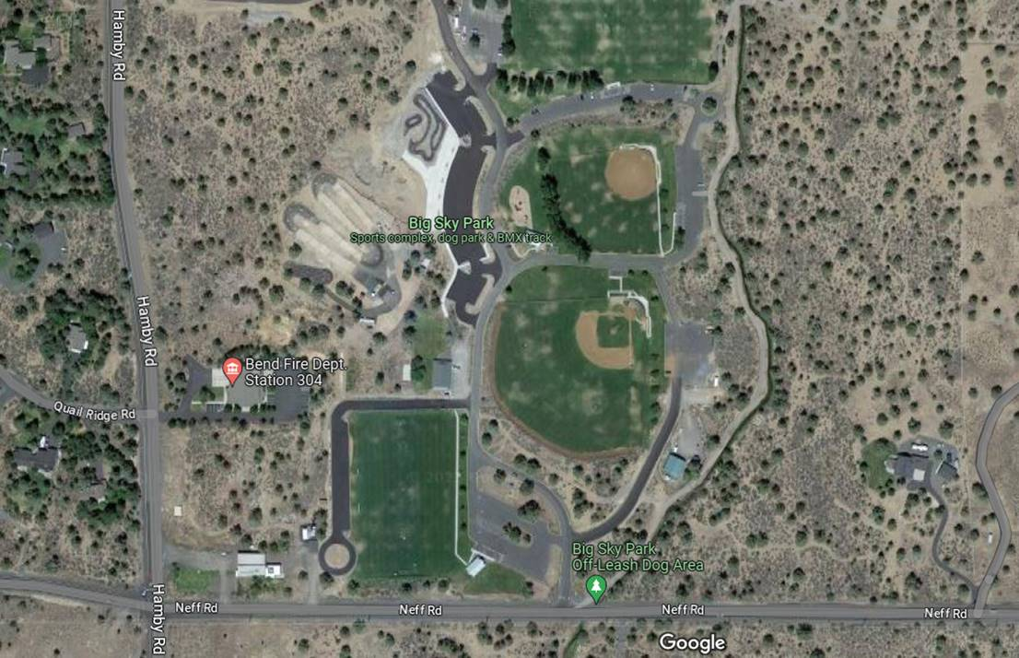
Big Sky Park- 21690 Neff Rd, Bend, OR 97701

PACKING ITEM LIST TO BRING
  Swim trunks |   Sun screen | 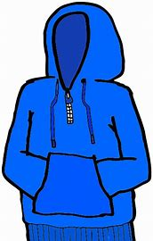  Sweatshirt/hoodie  Bend is high desert climate, warm/hot during the day and cool at night
  Metal cleats  Molded cleats (necessary if a game has to be played on turf field) |   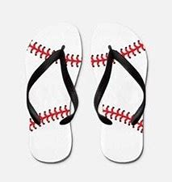  Swim shoes, flip flops |   Float tube (Float the Deschutes River- there are float tubes for rent)
    2-3 pairs of shoes; 1 pair of sturdy shoes if you want to go hiking. 1 pair of shoes to get around town walking, etc. |   Water bottle  Teams will need to supply their own water/gatorade/ drinks in the dugout |   Pin trading with other teams (optional)

Bendites have a saying: "show up and blow up," which means, come as you are, with no planning. Still, some things need a little planning ahead if you're heading to Bend, Oregon.
Insider tips, such as knowing where and how to get trail permits, properly selecting what to wear and understanding the art of blending in like a local, are key to a successful trip. Afraid you'll stick out like a sore out-of-town thumb when you get to Bend? Memorize this list, and you’ll be set for a crash landing in Oregon’s highest-profile outdoor vacation destination.

Keep the original inhabitants in mind while you explore
The ancestors of the first nomadic people to inhabit the Central Oregon landscape now reside on the Warm Springs Reservation, a sovereign nation to the north of Bend. Visitors are permitted at the Museum at Warm Springs, Indian Head Casino and a handful of dining establishments. Patronizing Warm Springs businesses is good juju.
The high desert is a delicate ecosystem, and resources are scarce. Because of this, early Wasco, Warm Springs Bands and Paiute people, now known as the Confederated Tribes of Warm Springs, wisely only seasonally inhabited the region. Unfortunately, the reservation faces an ongoing water crisis and has systemic issues accessing non-toxic, potable water.

Get your permits in advance
Permits are required for most of the fun outdoor stuff you'll want to do in Bend. If you're recreating on Deschutes National Forest land, you'll need a day or season recreation pass displayed on the dashboard of your vehicle. For highly trafficked areas like the Three Sisters Wilderness or the Central Cascades Wilderness, an additional permit is necessary. In the winter, a sno-park pass is required at many of the same sites that require a Deschutes National Forest pass. If you're thinking about visiting Smith Rock or any other state park, a separate pass is required.
Downtown Bend has metered parking paid by a smartphone app for all central areas.
Set yourself up for success by calling land managers ahead of your trip to clarify what passes are required. These rules are important to follow, and fines are issued to those who neglect the regulations.

Learn to use roundabouts before you arrive
Parking and driving can be quite congested in Bend during the high season. Though roundabouts instead of streetlights keep the flow moving, some folks don’t know proper roundabout etiquette. Check out this tutorial from the City of Bend to be sure you're ready to tackle the turnstiles.
To avoid driving altogether, check out the Ride Bend Free Shuttle Service which picks up and drops patrons off within a couple of mile radius of downtown, the Cascades East Transit system, the Mount Bachelor Shuttle, the Ride the River Deschutes River float shuttle and the Central Oregon Breeze.
Other alternatives to driving include, but are not limited to, walking, biking, skateboarding, inline skating or scootering. The city is also easily navigated by electric bikes. Rideshares like Uber and Lyft are available on demand.

Be nice, you’re in Bend
Bendites have another saying: "Be nice, you’re in Bend." If you want to stay incognito and not be mistaken for a tourist, keep this in mind. A red flag giveaway that is sure to blow your cover: being rude to waitstaff or anyone in the service or hospitality industry. With deep roots in ski bum and dirt back outdoor culture – which is what put Bend on the map to begin with – many locals are still living that lifestyle. In Bend, the pace of service is different than in a big city, consider being extra nice while waiting to be seated in restaurants, collecting take-out, renting or purchasing gear and so on.
Don't just be nice to people, act like a local and be nice to the environment, too. Being a steward of the outdoor spaces and the public lands we call home is critical. Enjoy Protect Respect is an awareness campaign that can guide you in best practices when floating the Deschutes River. The Leave no Trace principles are also helpful when visiting the wilderness spaces surrounding Bend.

Bust out your Patagucci
You’ve heard that dressing for success is key for fitting in, right? In Bend, you can’t go wrong with Patagonia's casual outdoor wear, or as locals affectionately refer to the outdoor brand, "Patagucci" (a combination of Patagonia and designer brand, Gucci). There’s even a signature, locally owned, Patagonia store in Bend. Start with staples like any style of puffy jacket (goose down) and a signature winter hat. From there, t-shirts, running garments and climbing apparel are all within bounds. Sporting the Patagonia label in Bend is essentially a signal statement to everyone you encounter that, you could, in fact, be a local. Just be sure the gear isn’t too fresh. Worn in outer layers will earn you more street cred.
Other popular brands include Columbia, Pendleton, Danner, Black Diamond and anything surf, snowboard or skate. Trucker hats, flannels and overalls never go out of fashion in Bend.

Don’t forget Bend has a great arts & entertainment scene
With incredible performance venues around town, Bend is constantly attracting top talent that’s both local and international. The Hayden Homes Amphitheater, the Domino Room and the Volcanic Theater Pub all bring in the musical talent while the comedy scene at Craft Kitchen and Silvermoon Brewery will have you in stitches weekly.

